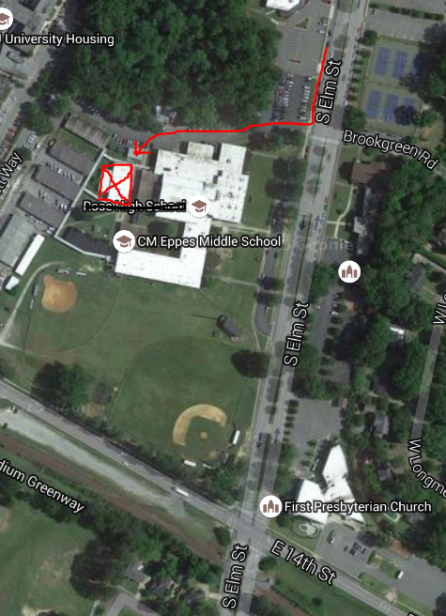

Annex is behind CM Eppes Middle School. Enter on the North entrance (to the right side of the school).

Drive back past the cafeteria and the annex is on your left.